mobilenet



In this project you will use a machine learning model to recognise objects in photos.

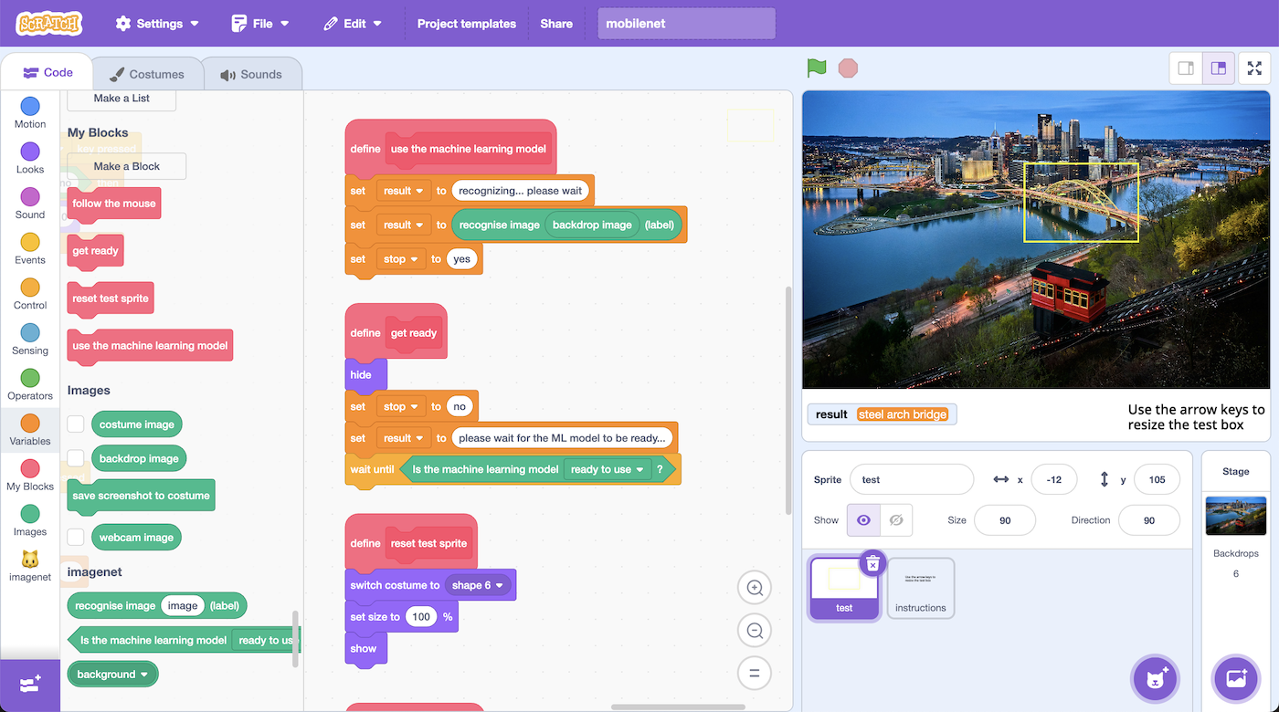

This project worksheet is licensed under a Creative Commons Attribution Non-Commercial Share-Alike License

http://creativecommons.org/licenses/by-nc-sa/4.0/

1. Go to [https://machinelearningforkids.co.uk/scratch](https://machinelearningforkids.co.uk/scratch/) in a web browser
2. Click on “**Project templates**”
3. Click on “**mobilenet**”  
   *Wait for the project to download – it is large, so this may take a moment.*
4. Look at the code in the “**test**” sprite  
   *Try to predict what you think this code will do before you run it.*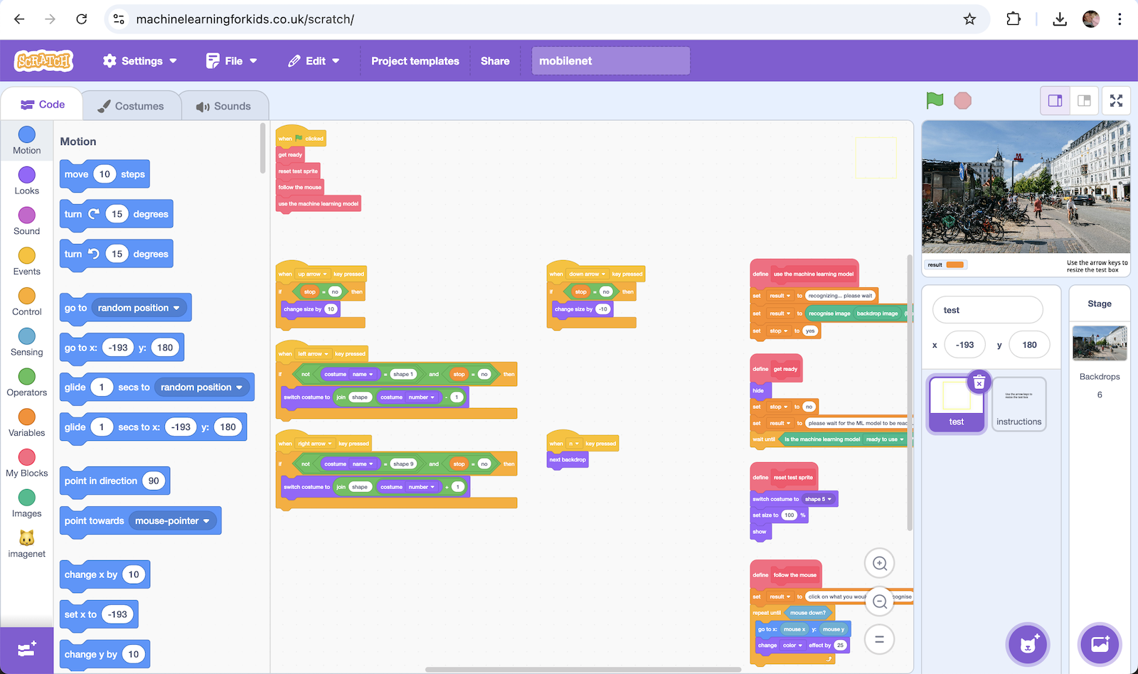
5. Click on the **full-screen** button, then click on the **Green Flag**  
   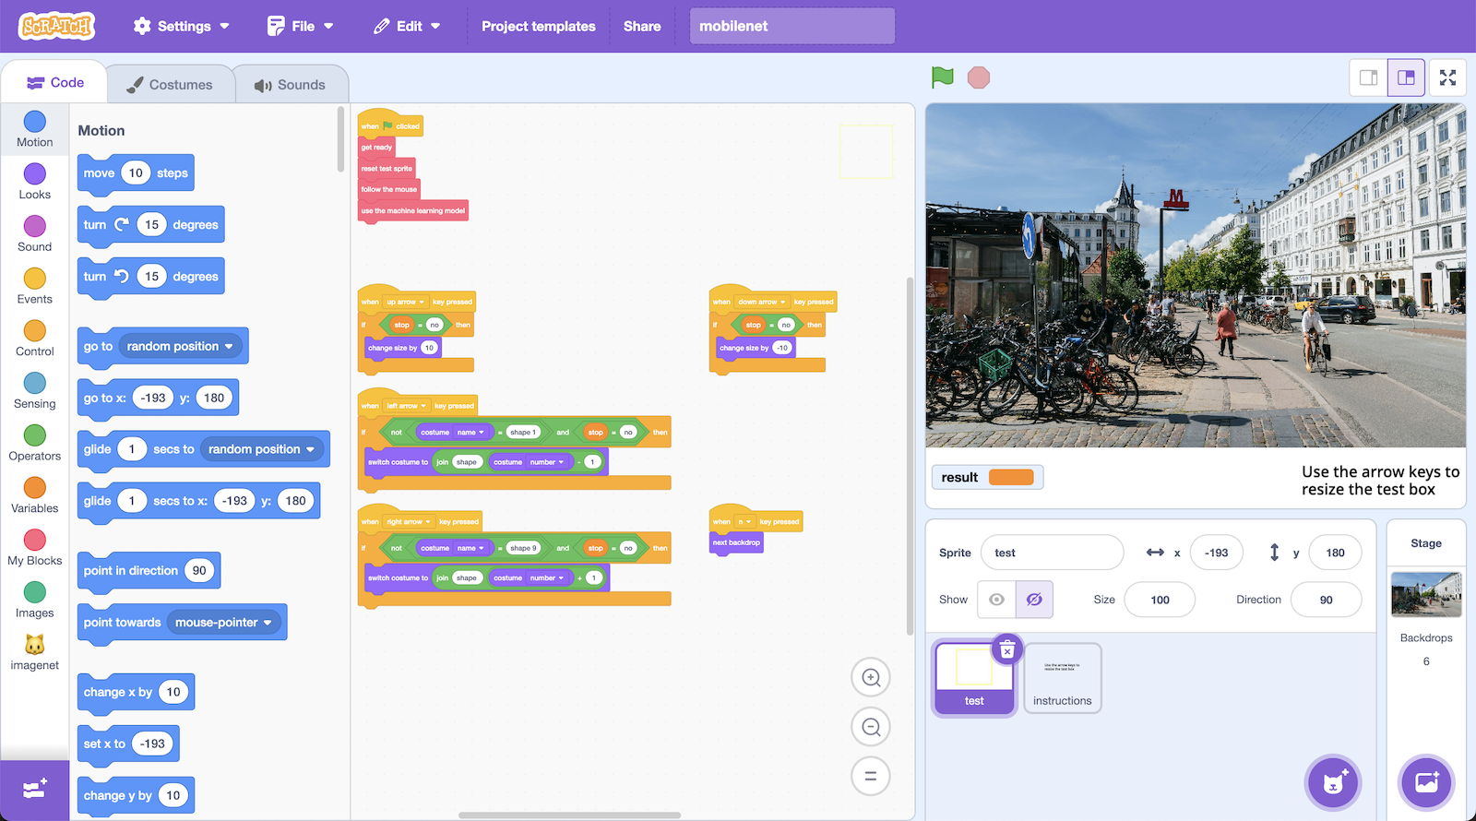
6. Choose an object in the scene – for example, the coffee mug
7. Move the mouse to move the flashing, coloured box.   
   Position the box so the object you’ve chosen is in the middle of the box.  
   Use the arrow keys to change the size and shape of the test box:  
    **up** – makes the test box larger  
    **down** – makes the test box smaller  
    **left** – makes the test box taller / narrower  
    **right** – makes the test shorter / wider
8. Click the mouse   
   *A machine learning model will attempt to recognize the image contained in the coloured box.   
   The result will be displayed at the bottom.*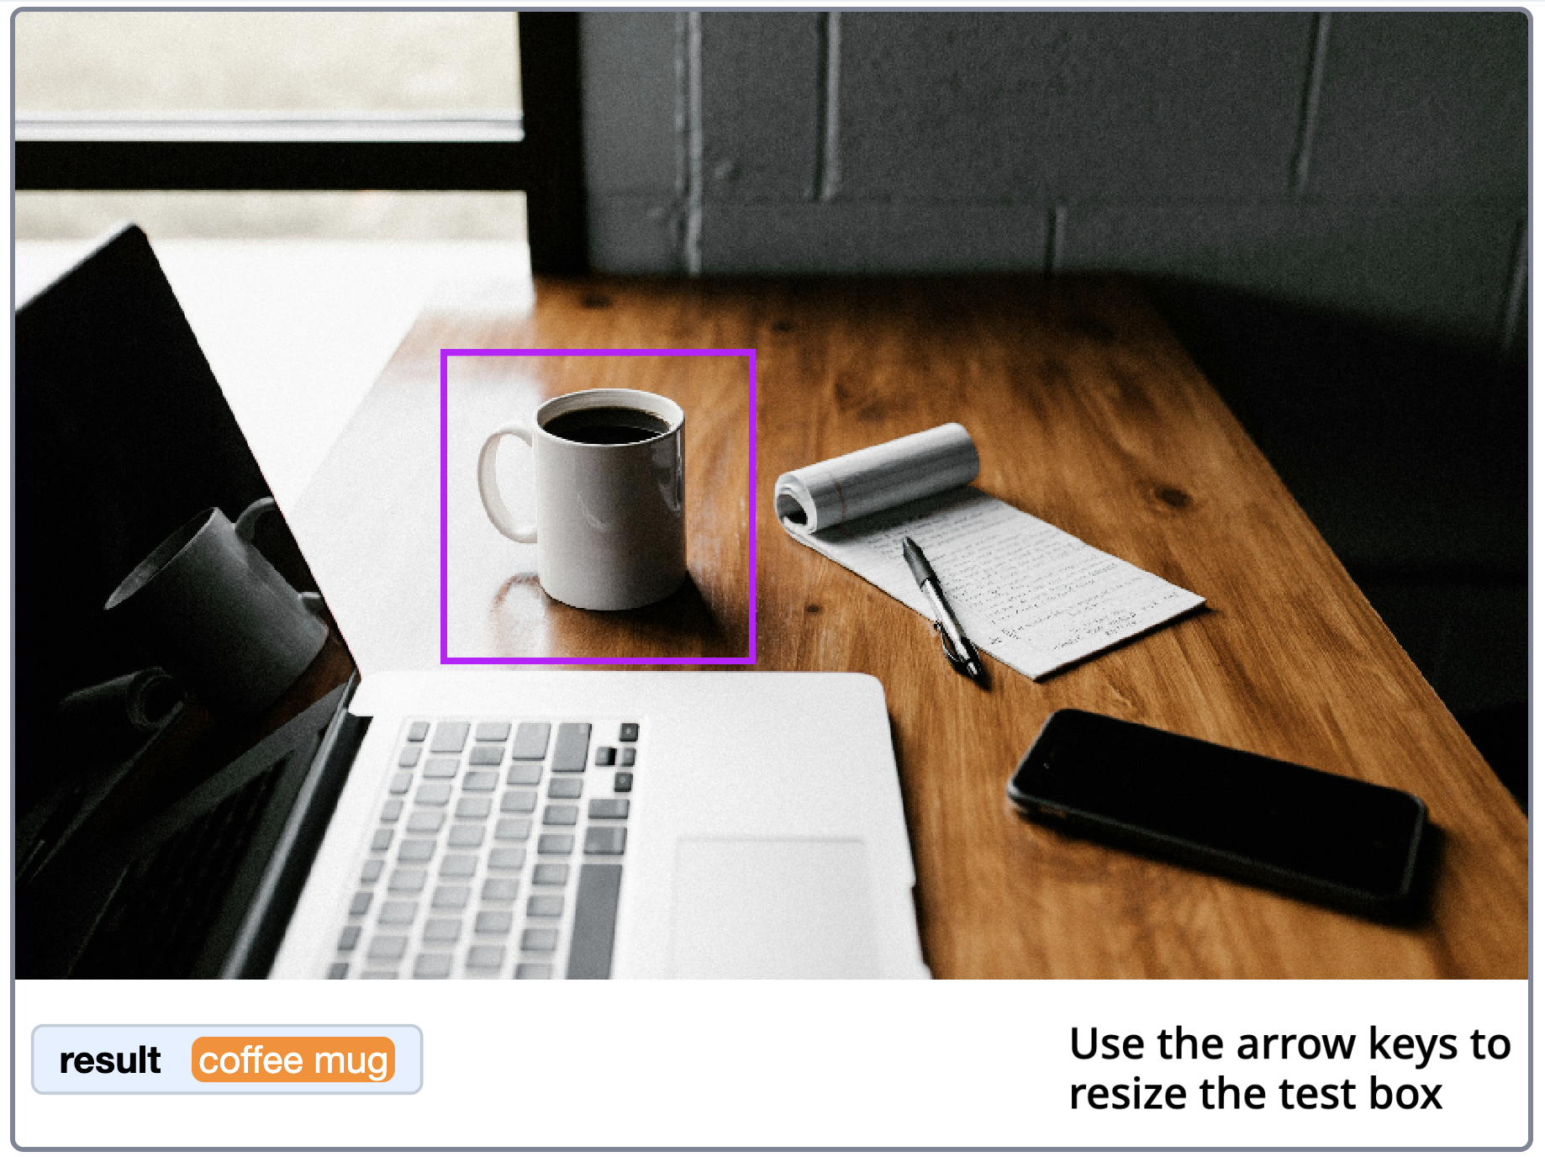
9. Press the **N** button on your keyboard to move to the next scene
10. Click the **Green Flag** and try recognising something else.   
    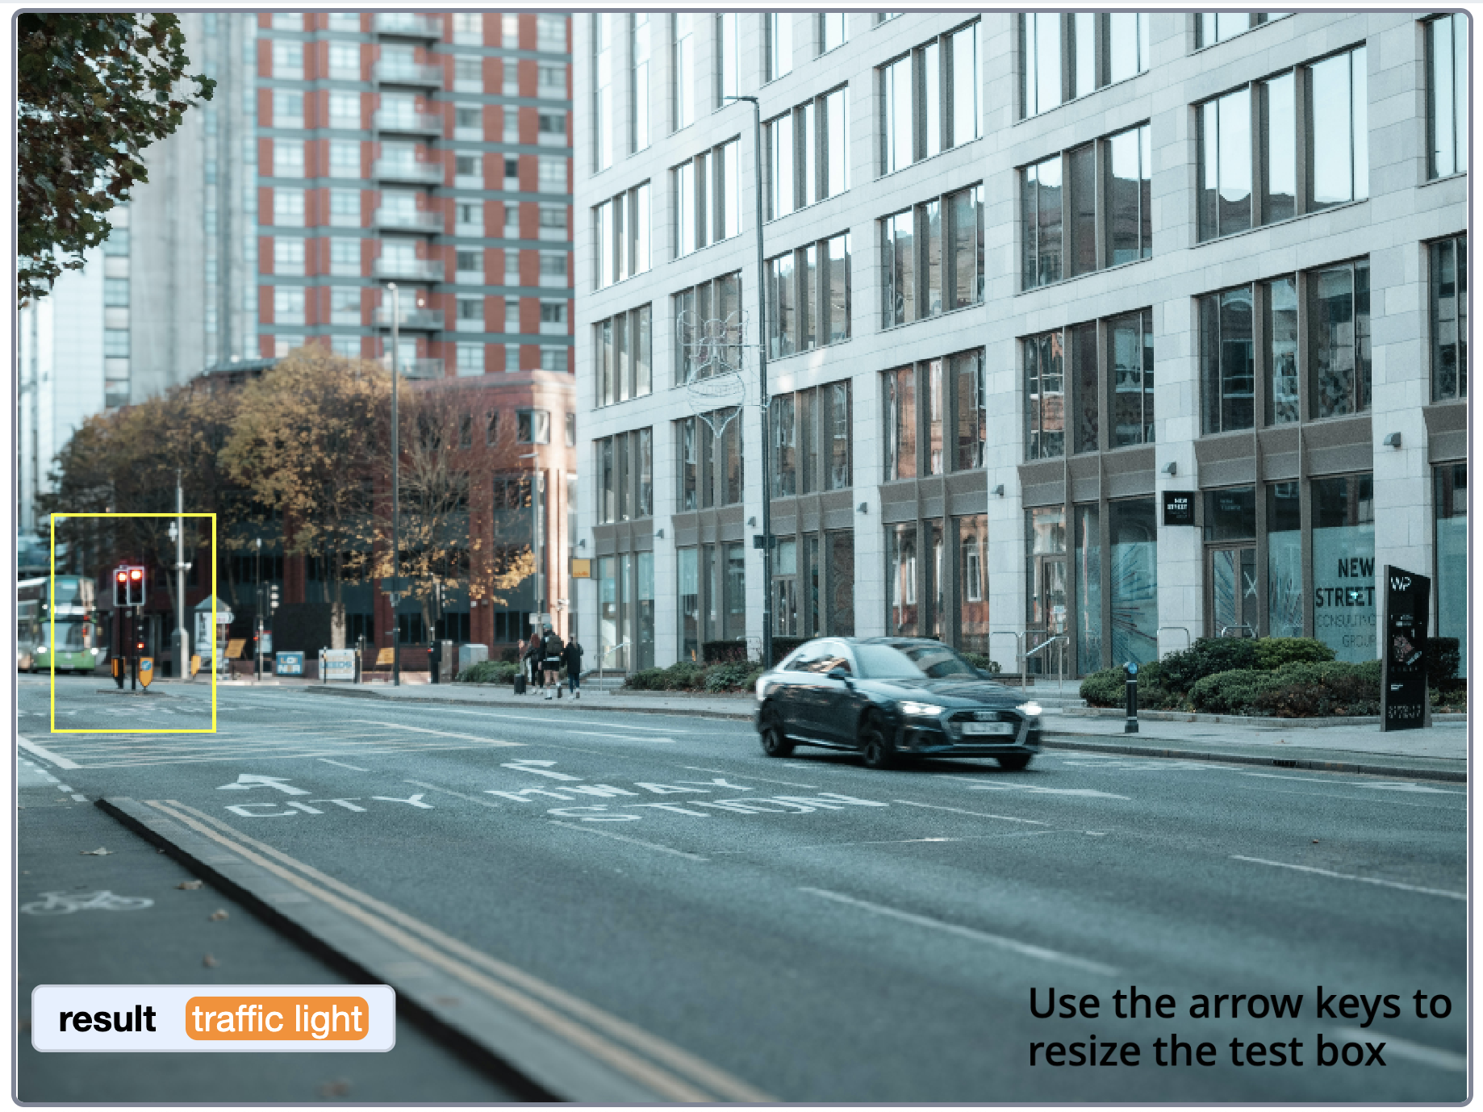
11. Go through a few scenes. Try a few objects in each scene.   
    *What does the model recognize correctly? What does it get wrong?*   
    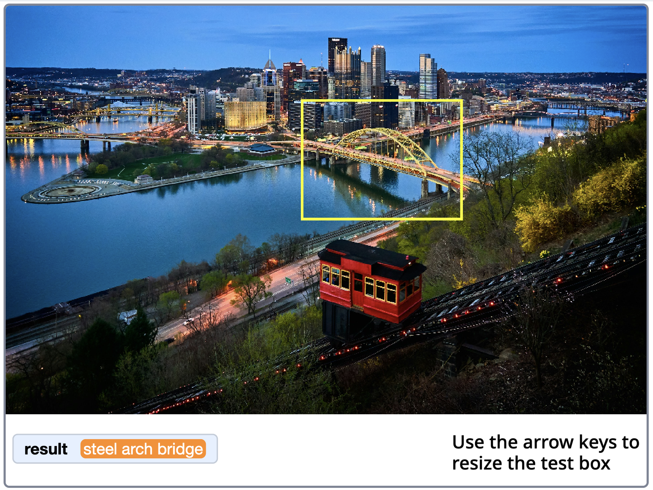
12. How specific is the model in your testing?   
    *For example, instead of “dog”, it attempted to recognise a specific breed. Was it correct?*  
    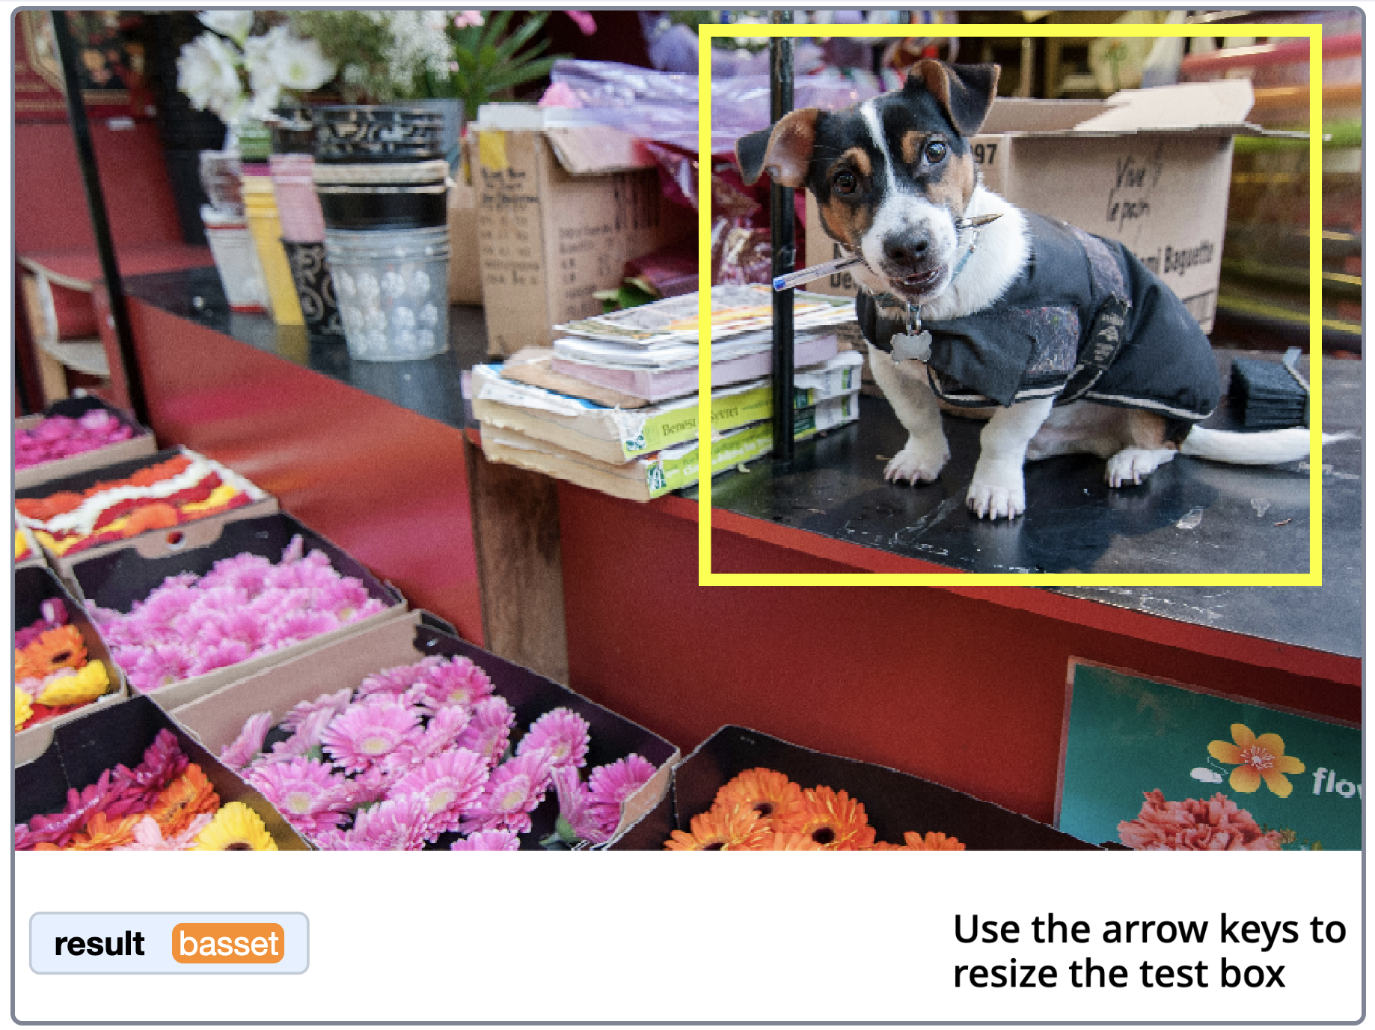
13. What happens if you select multiple objects?  
    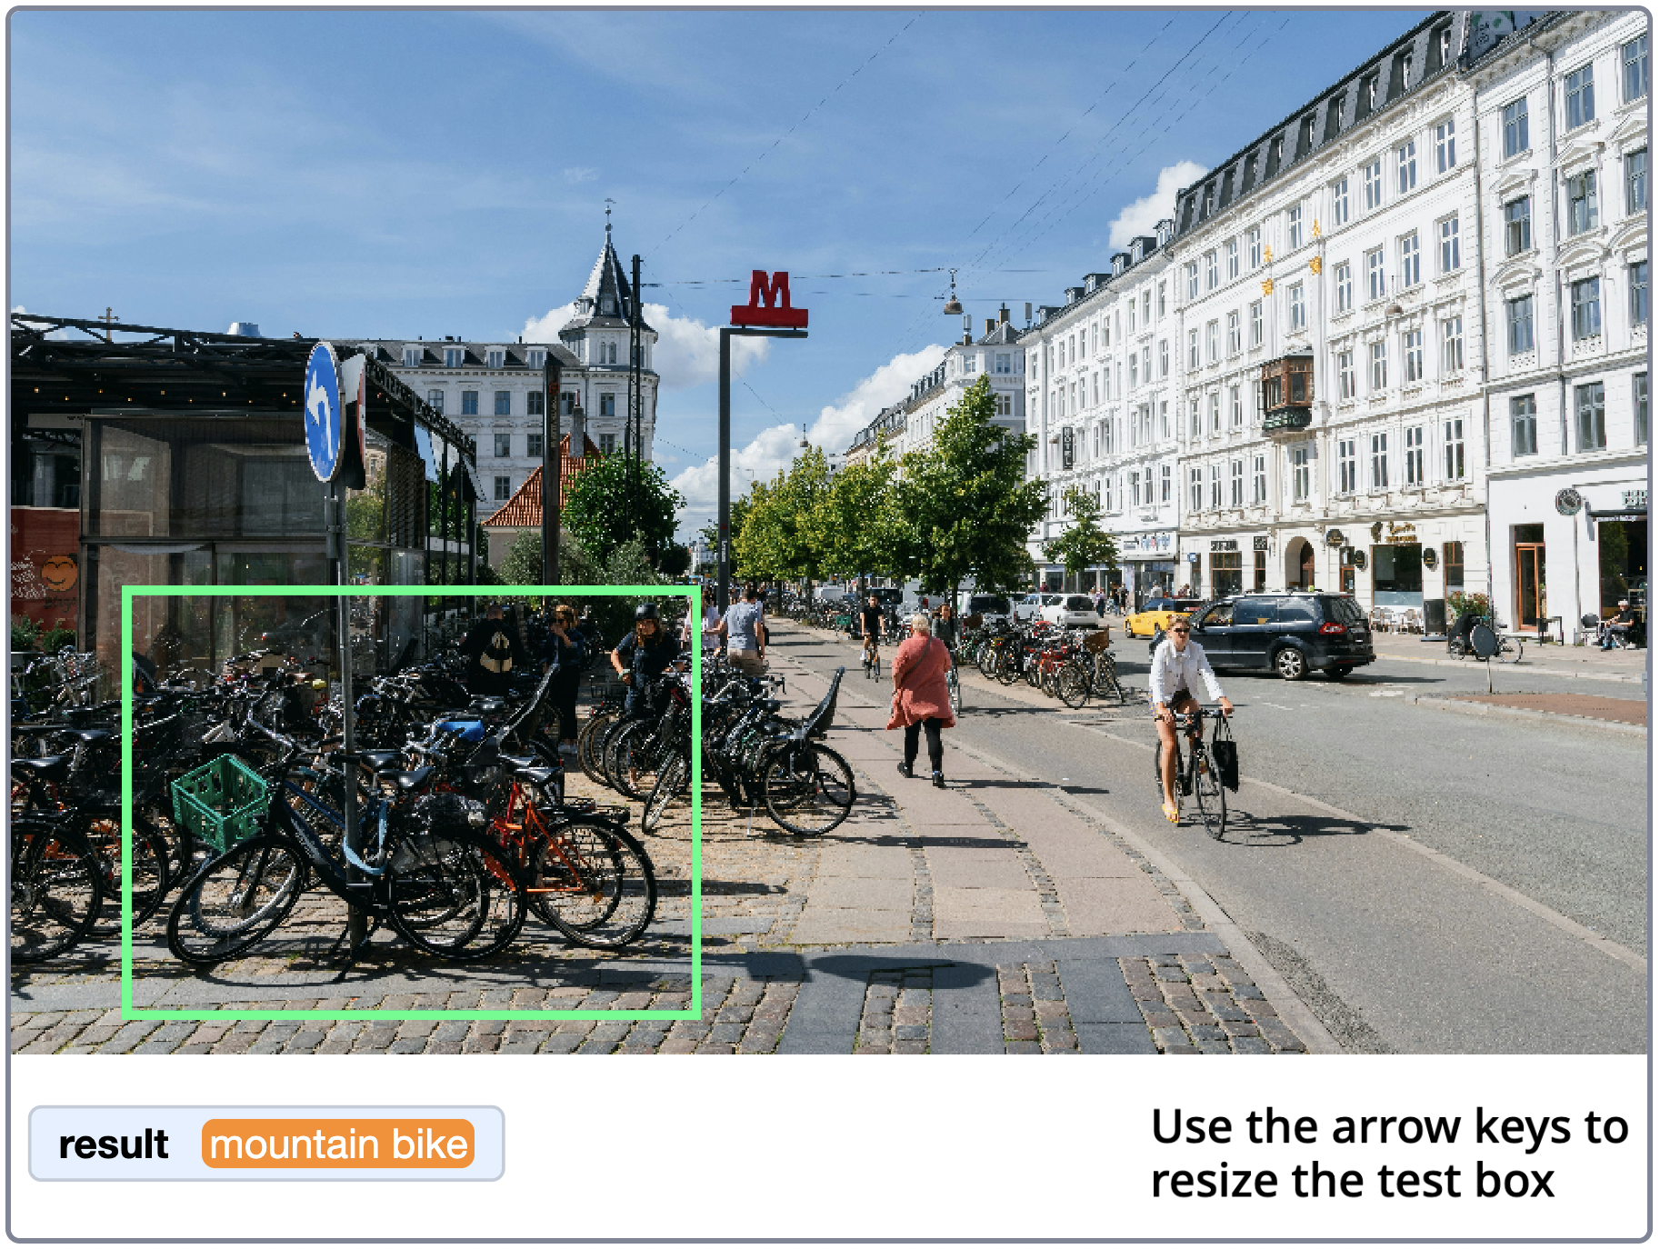
14. What objects has this model been trained to recognize?   
    *Exit full-screen mode and scroll through the list of labels available in the reporter block in the imagenet section.  
    You should see a very long list of classes. These are the objects that the machine learning model has been trained to recognise.   
    The predictions you have seen in your testing will all be in this list.  
    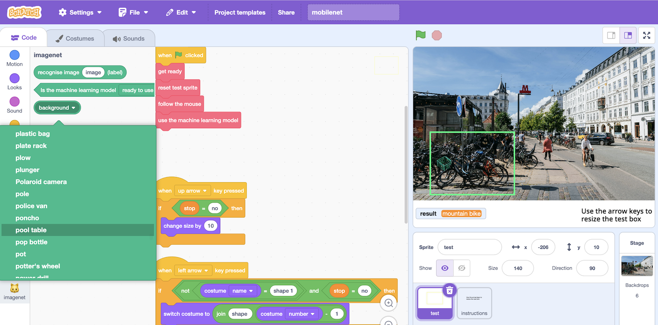*
15. What do you think of this model?   
    *Like all machine learning models, it makes mistakes. Some objects you wanted it to recognize will have been incorrectly recognized.  
    How many did it get correct?   
    What was it good at recognizing? What was it bad at recognizing?*
16. **How many** pictures you think were collected to train this model?   
    **Where** do you think the images were collected from?  
    *Try to guess before you move on to the next step.   
    Write down your guesses to help you remember.*
17. In a new web browser window, go to [**https://ibm.biz/mobilenet**](https://ibm.biz/mobilenet)   
    *When we use a machine learning system, it is helpful if the creators of the system publish the “Model card” – where they tell you how it was created.  
    The model you have been using is* ***Mobilenet v3****.   
    This page has the model card for this machine learning model.*
18. Have a look at the model card  
    *Model cards are complicated, so don’t worry that you won’t understand all of it. But there are some interesting things to find here.*   
    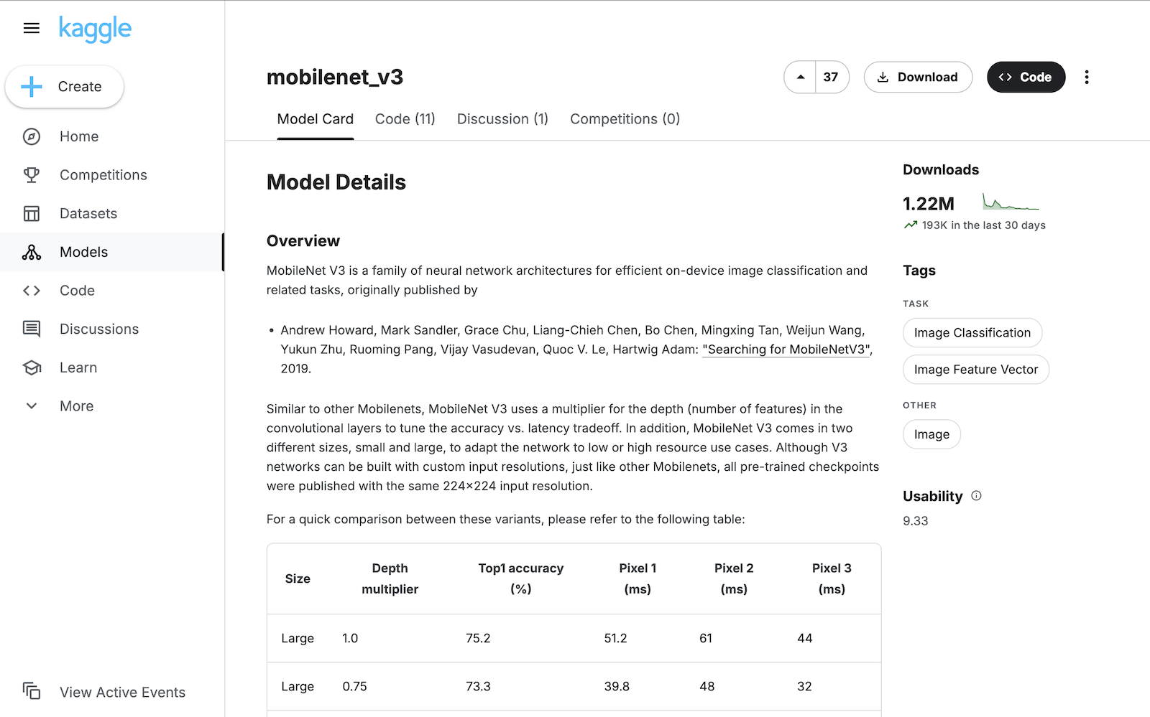 *For example, here are the names of the people who first created it.*  
    *There are two versions: “large” (22.1 MB) and “small” (10.34 MB).   
    The “large” model has a higher accuracy (it makes more correct predictions).*  
      
    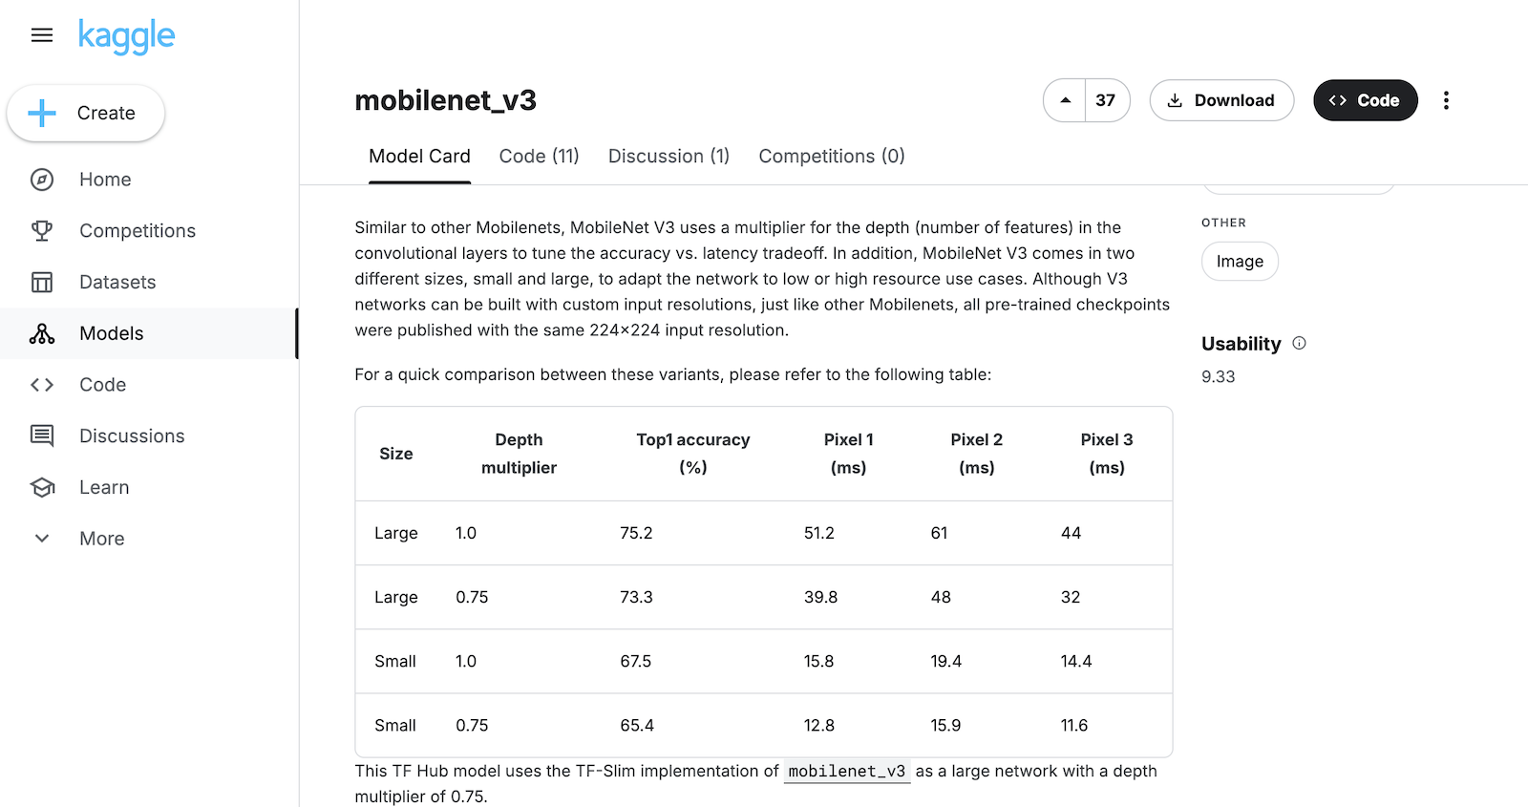  
      
    *You used the “small” model in this project. Why do you think the project used the small version if the large model gives better answers?*   
    *The model card explains that the training data used to create this model was the “****imagenet****” set of photos.   
    This is such a famous training set that they don’t explain what it is, so we need to look elsewhere for more detail about this.*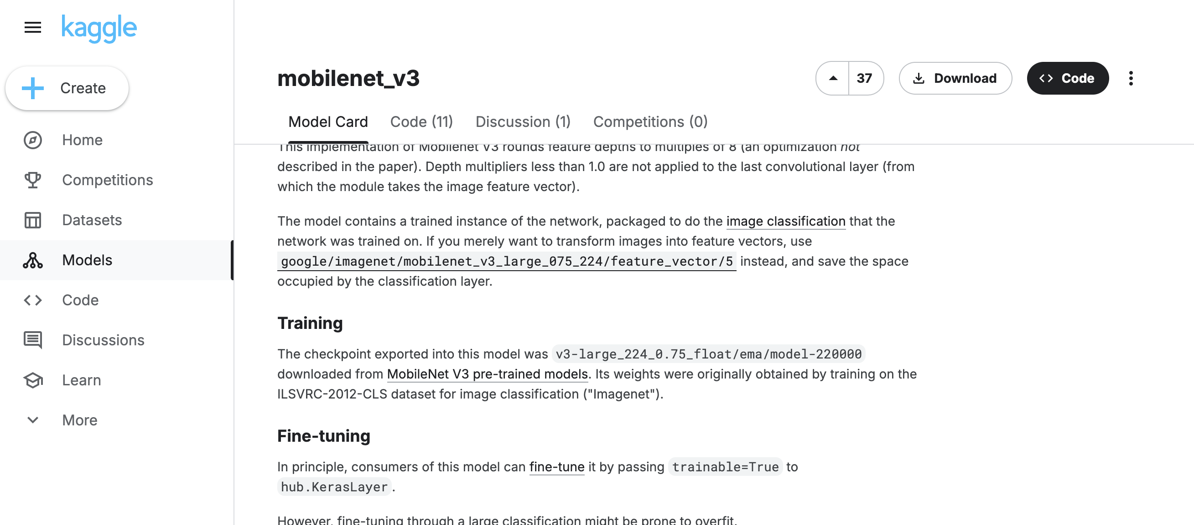   
      
    *You can find information about imagenet at* [*https://****image-net.org***](https://image-net.org)  
      
    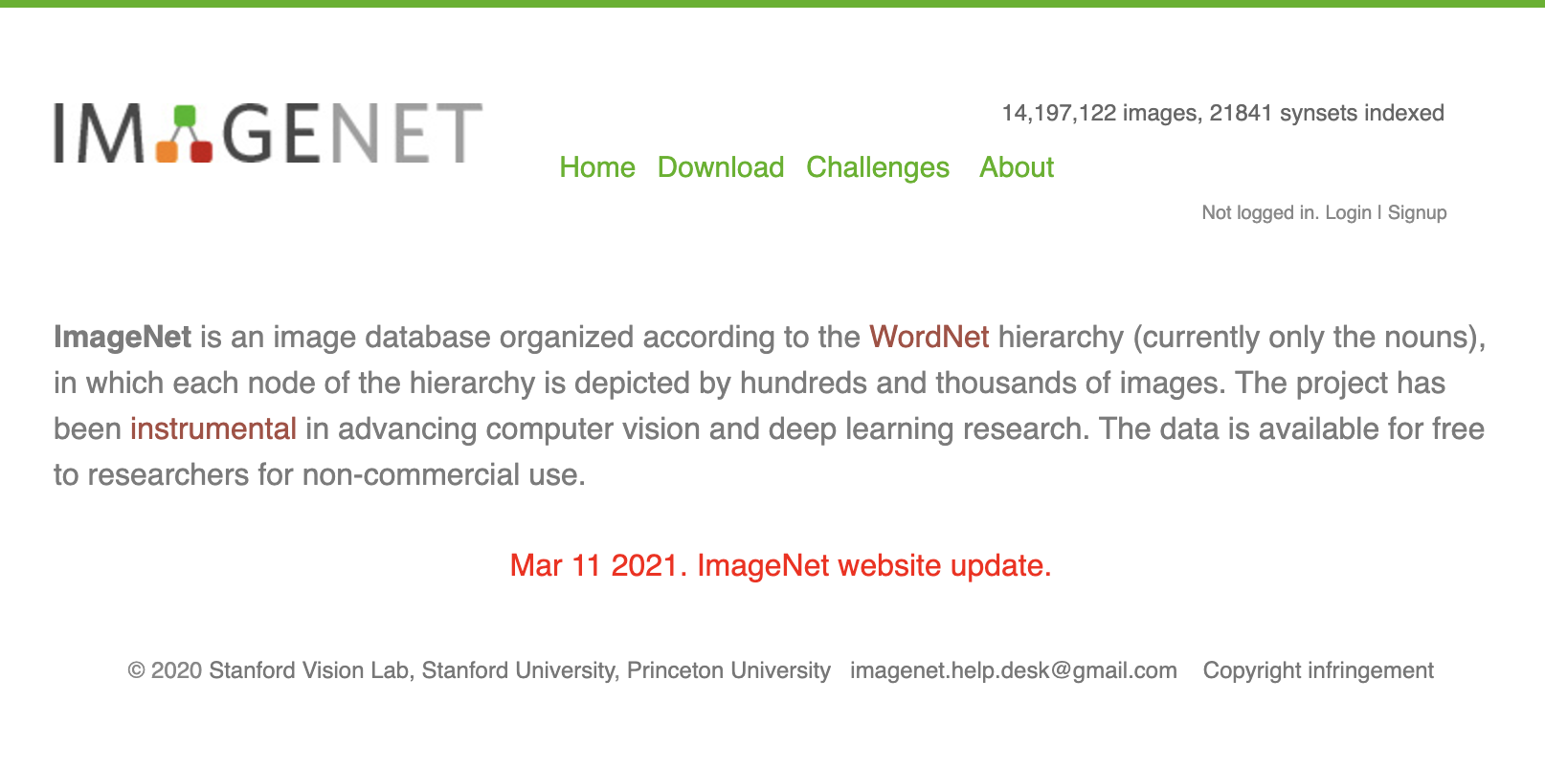  
      
    *This tells you that imagenet contains* ***over 14 million images****.   
    Compare that with your guess. Were you close?   
      
    It describes how images were found from searching across the Internet, especially using searches in Google, MSN, Yahoo, and Flickr.   
      
    All of these 14 million images needed to be labelled by a human to train the computer how to do this. This was done by* ***crowd-sourcing*** *(paying lots and lots of humans to each label some images).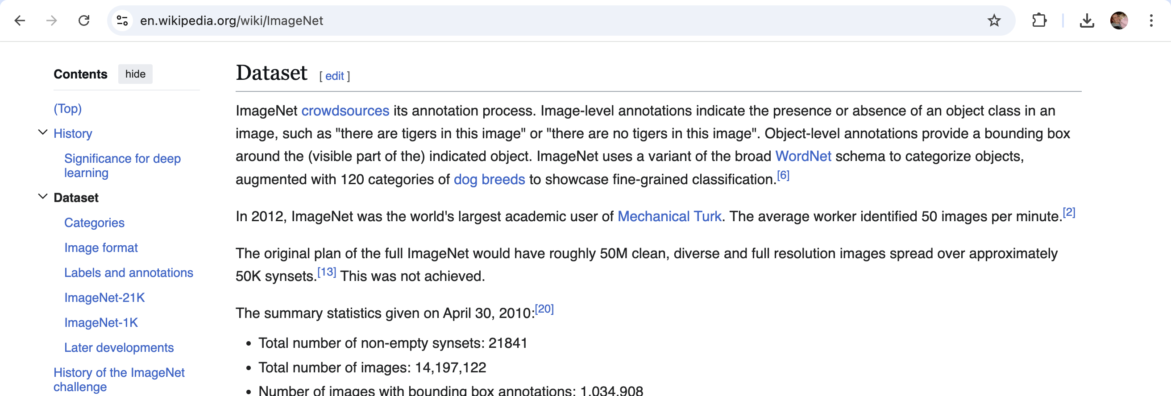 This was* ***even more*** *work than asking people to label 14 million images.   
      
    People make mistakes, so every picture had to be labelled by a few different people.   
    If the people all agreed, then their answers could be trusted.   
    If they didn’t agree, more people needed to label the image.  
      
    Every training image was labelled by between 2 – 5 people.****Did you guess what a huge project it was to train this model?***
19. Compare what you’ve learned about the mobilenet model with what you thought of how good the model is at recognizing things.  
    *Remember, you’ve been using the “small” variant of the model.   
    The “large” variant is a little better than what you’ve seen.*
20. Find a new picture to test the model with  
    *Search the web for scenes, landscapes, photos from towns, office photos, photos of shops…   
      
    The best images for this have several objects you can use to test the model.  
      
    You can take your own digital photos if you want.*
21. Upload your new photo as a new **backdrop**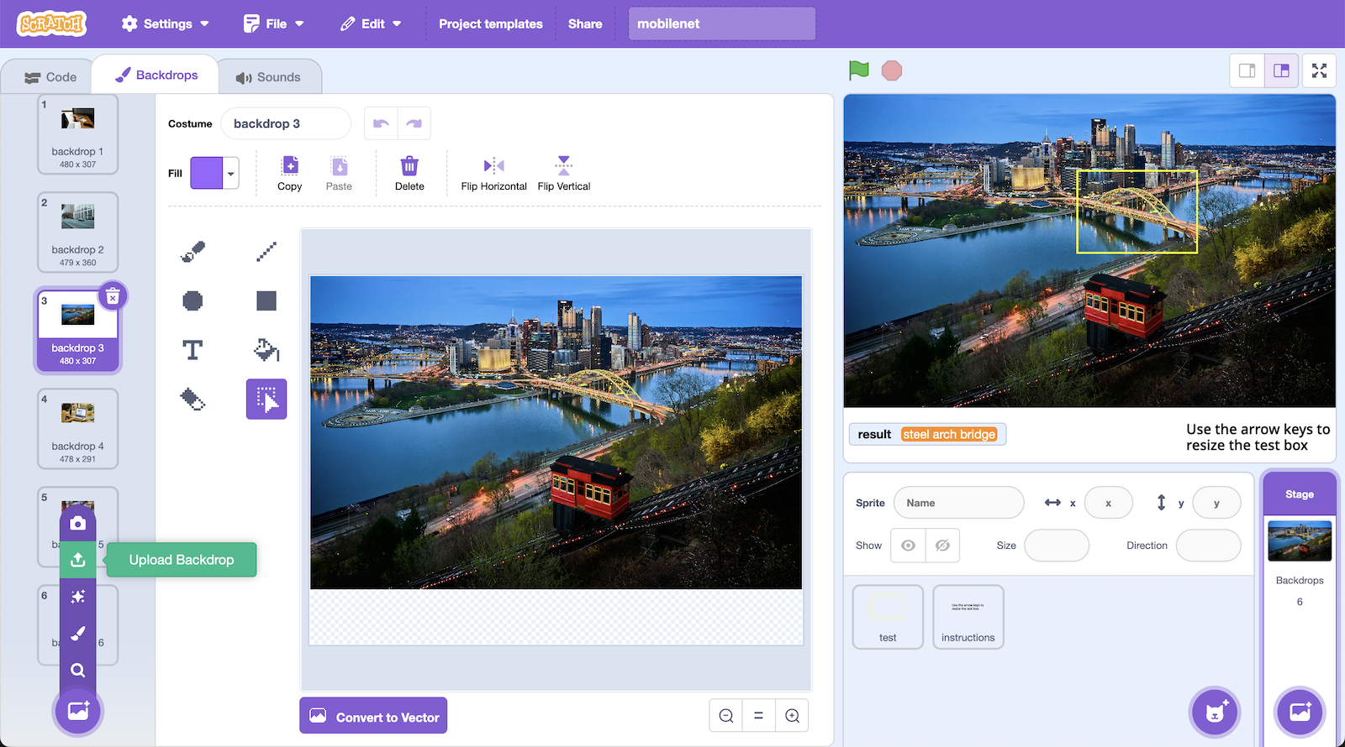
22. Try testing mobilenet with your new image.   
    *How does it do?*

**What have you done?**

You’ve been using one of the most well-known models in machine learning.

You’ve seen that machine learning models are not perfect. They are impressive. They can do a lot. But they make mistakes.

You’ve learned what a “model card” is. Not all artificial intelligence systems publish a model card, but it is a good practice that encourages transparency.

You have seen the amount of work that goes into collecting the training sets needed to create real-world machine learning models.

**Ideas and Extensions**

Now that you’ve finished, why not give one of these ideas a try?

Or come up with one of your own?